Plus

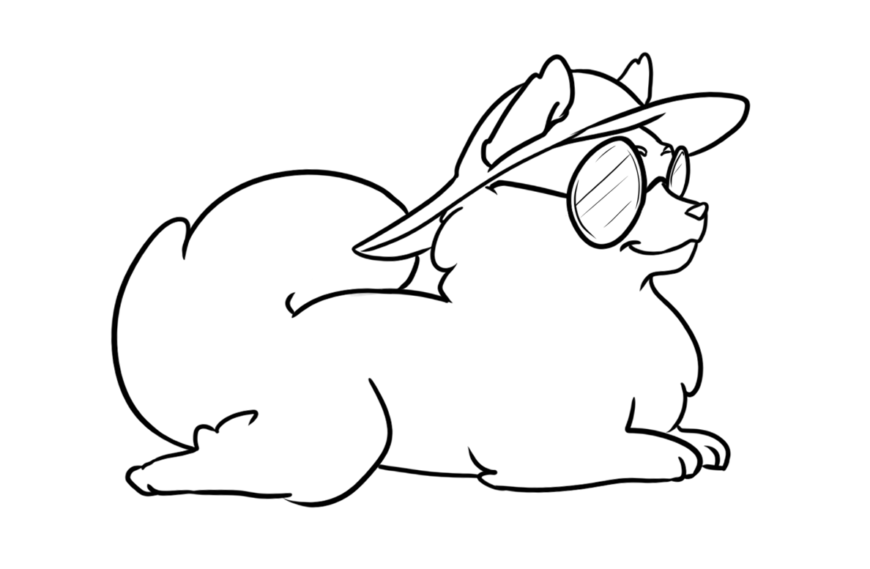

Regn plus stykkerne og sæt streg til det rigtige tal.

|  |  |  |
| --- | --- | --- |
| 1 + 2 |  | 6 |

|  |  |  |
| --- | --- | --- |
| 1 + 5 |  | 1 |

|  |  |  |
| --- | --- | --- |
| 1 + 0 |  | 3 |

|  |  |  |
| --- | --- | --- |
| 1 + 3 |  | 4 |

|  |  |  |
| --- | --- | --- |
| 1 + 4 |  | 2 |

|  |  |  |
| --- | --- | --- |
| 1 + 1 |  | 5 |

Plus LØSNING



Regn plus stykkerne og sæt streg til det rigtige tal.

|  |  |  |
| --- | --- | --- |
| 1 + 2 |  | 6 |

|  |  |  |
| --- | --- | --- |
| 1 + 5 |  | 1 |

|  |  |  |
| --- | --- | --- |
| 1 + 0 |  | 3 |

|  |  |  |
| --- | --- | --- |
| 1 + 3 |  | 4 |

|  |  |  |
| --- | --- | --- |
| 1 + 4 |  | 2 |

|  |  |  |
| --- | --- | --- |
| 1 + 1 |  | 5 |

Plus

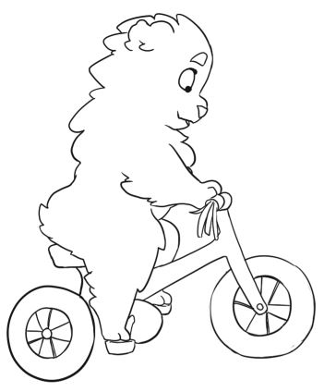

Regn plus stykkerne og sæt streg til det rigtige tal.

|  |  |  |
| --- | --- | --- |
| 1 + 7 |  | 12 |

|  |  |  |
| --- | --- | --- |
| 1 + 9 |  | 8 |

|  |  |  |
| --- | --- | --- |
| 1 + 11 |  | 9 |

|  |  |  |
| --- | --- | --- |
| 1 + 8 |  | 7 |

|  |  |  |
| --- | --- | --- |
| 1 + 10 |  | 10 |

|  |  |  |
| --- | --- | --- |
| 1 + 6 |  | 11 |

Plus LØSNING



Regn plus stykkerne og sæt streg til det rigtige tal.

|  |  |  |
| --- | --- | --- |
| 1 + 7 |  | 12 |

|  |  |  |
| --- | --- | --- |
| 1 + 9 |  | 8 |

|  |  |  |
| --- | --- | --- |
| 1 + 11 |  | 9 |

|  |  |  |
| --- | --- | --- |
| 1 + 8 |  | 7 |

|  |  |  |
| --- | --- | --- |
| 1 + 10 |  | 10 |

|  |  |  |
| --- | --- | --- |
| 1 + 6 |  | 11 |

Plus

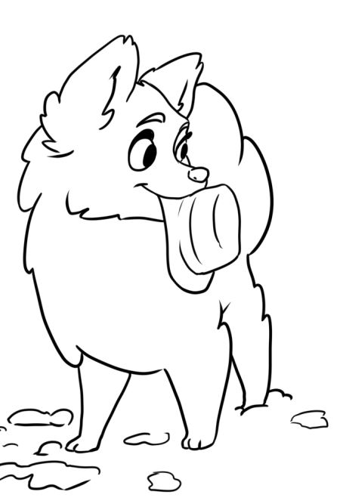

Regn plus stykkerne og sæt streg til det rigtige tal.

|  |  |  |
| --- | --- | --- |
| 2+ 4 |  | 4 |

|  |  |  |
| --- | --- | --- |
| 2 + 2 |  | 5 |

|  |  |  |
| --- | --- | --- |
| 2 + 0 |  | 6 |

|  |  |  |
| --- | --- | --- |
| 2 + 3 |  | 7 |

|  |  |  |
| --- | --- | --- |
| 2 + 1 |  | 2 |

|  |  |  |
| --- | --- | --- |
| 2 + 5 |  | 3 |

Plus LØSNING



Regn plus stykkerne og sæt streg til det rigtige tal.

|  |  |  |
| --- | --- | --- |
| 2+ 4 |  | 4 |

|  |  |  |
| --- | --- | --- |
| 2 + 2 |  | 5 |

|  |  |  |
| --- | --- | --- |
| 2 + 0 |  | 6 |

|  |  |  |
| --- | --- | --- |
| 2 + 3 |  | 7 |

|  |  |  |
| --- | --- | --- |
| 2 + 1 |  | 2 |

|  |  |  |
| --- | --- | --- |
| 2 + 5 |  | 3 |

Plus

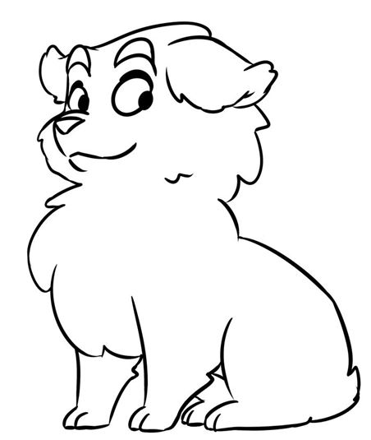

Regn plus stykkerne og sæt streg til det rigtige tal.

|  |  |  |
| --- | --- | --- |
| 2+ 8 |  | 12 |

|  |  |  |
| --- | --- | --- |
| 2 + 10 |  | 9 |

|  |  |  |
| --- | --- | --- |
| 2 + 7 |  | 11 |

|  |  |  |
| --- | --- | --- |
| 2 + 11 |  | 10 |

|  |  |  |
| --- | --- | --- |
| 2 + 9 |  | 8 |

|  |  |  |
| --- | --- | --- |
| 2 + 6 |  | 13 |

Plus LØSNING



Regn plus stykkerne og sæt streg til det rigtige tal.

|  |  |  |
| --- | --- | --- |
| 2+ 8 |  | 12 |

|  |  |  |
| --- | --- | --- |
| 2 + 10 |  | 9 |

|  |  |  |
| --- | --- | --- |
| 2 + 7 |  | 11 |

|  |  |  |
| --- | --- | --- |
| 2 + 11 |  | 10 |

|  |  |  |
| --- | --- | --- |
| 2 + 9 |  | 8 |

|  |  |  |
| --- | --- | --- |
| 2 + 6 |  | 13 |

Plus

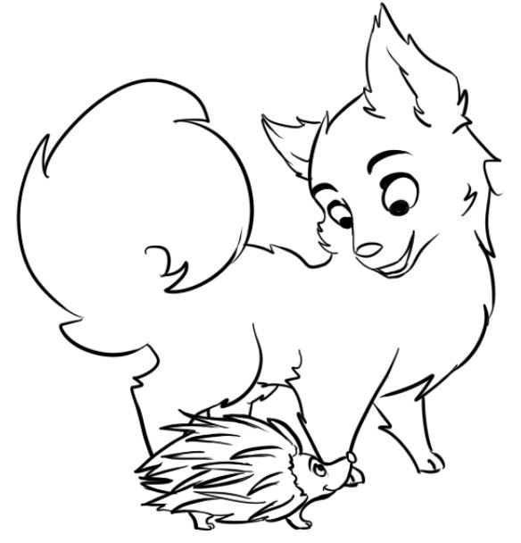

Regn plus stykkerne og sæt streg til det rigtige tal.

|  |  |  |
| --- | --- | --- |
| 3 + 2 |  | 4 |

|  |  |  |
| --- | --- | --- |
| 3 + 5 |  | 6 |

|  |  |  |
| --- | --- | --- |
| 3 + 1 |  | 5 |

|  |  |  |
| --- | --- | --- |
| 3 + 6 |  | 8 |

|  |  |  |
| --- | --- | --- |
| 3 + 4 |  | 9 |

|  |  |  |
| --- | --- | --- |
| 3 + 3 |  | 7 |

Plus LØSNING



Regn plus stykkerne og sæt streg til det rigtige tal.

|  |  |  |
| --- | --- | --- |
| 3 + 2 |  | 4 |

|  |  |  |
| --- | --- | --- |
| 3 + 5 |  | 6 |

|  |  |  |
| --- | --- | --- |
| 3 + 1 |  | 5 |

|  |  |  |
| --- | --- | --- |
| 3 + 6 |  | 8 |

|  |  |  |
| --- | --- | --- |
| 3 + 4 |  | 9 |

|  |  |  |
| --- | --- | --- |
| 3 + 3 |  | 7 |

Plus

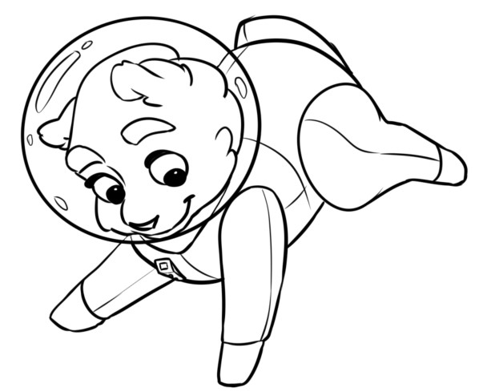

Regn plus stykkerne og sæt streg til det rigtige tal.

|  |  |  |
| --- | --- | --- |
| 3 + 8 |  | 14 |

|  |  |  |
| --- | --- | --- |
| 3 + 10 |  | 12 |

|  |  |  |
| --- | --- | --- |
| 3 + 7 |  | 11 |

|  |  |  |
| --- | --- | --- |
| 3 + 12 |  | 13 |

|  |  |  |
| --- | --- | --- |
| 3 + 11 |  | 10 |

|  |  |  |
| --- | --- | --- |
| 3 + 9 |  | 15 |

Plus LØSNING



Regn plus stykkerne og sæt streg til det rigtige tal.

|  |  |  |
| --- | --- | --- |
| 3 + 8 |  | 14 |

|  |  |  |
| --- | --- | --- |
| 3 + 10 |  | 12 |

|  |  |  |
| --- | --- | --- |
| 3 + 7 |  | 11 |

|  |  |  |
| --- | --- | --- |
| 3 + 12 |  | 13 |

|  |  |  |
| --- | --- | --- |
| 3 + 11 |  | 10 |

|  |  |  |
| --- | --- | --- |
| 3 + 9 |  | 15 |

Plus

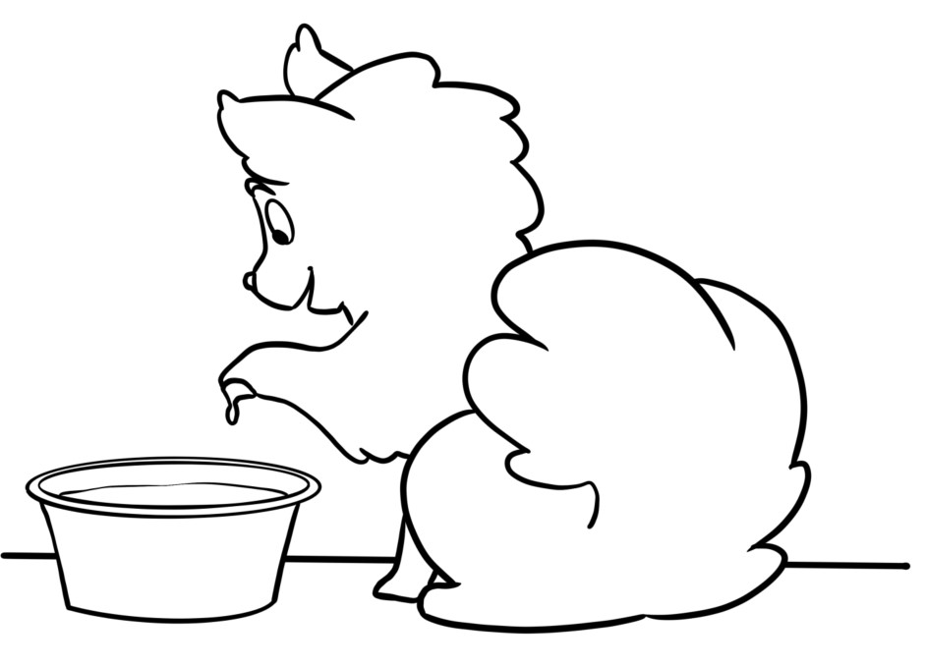

Regn plus stykkerne og sæt streg til det rigtige tal.

|  |  |  |
| --- | --- | --- |
| 4 + 2 |  | 5 |

|  |  |  |
| --- | --- | --- |
| 4 + 4 |  | 9 |

|  |  |  |
| --- | --- | --- |
| 4 + 1 |  | 6 |

|  |  |  |
| --- | --- | --- |
| 4 + 6 |  | 7 |

|  |  |  |
| --- | --- | --- |
| 4 + 5 |  | 10 |

|  |  |  |
| --- | --- | --- |
| 4 + 3 |  | 8 |

Plus LØSNING



Regn plus stykkerne og sæt streg til det rigtige tal.

|  |  |  |
| --- | --- | --- |
| 4 + 2 |  | 5 |

|  |  |  |
| --- | --- | --- |
| 4 + 4 |  | 9 |

|  |  |  |
| --- | --- | --- |
| 4 + 1 |  | 6 |

|  |  |  |
| --- | --- | --- |
| 4 + 6 |  | 7 |

|  |  |  |
| --- | --- | --- |
| 4 + 5 |  | 10 |

|  |  |  |
| --- | --- | --- |
| 4 + 3 |  | 8 |

Plus

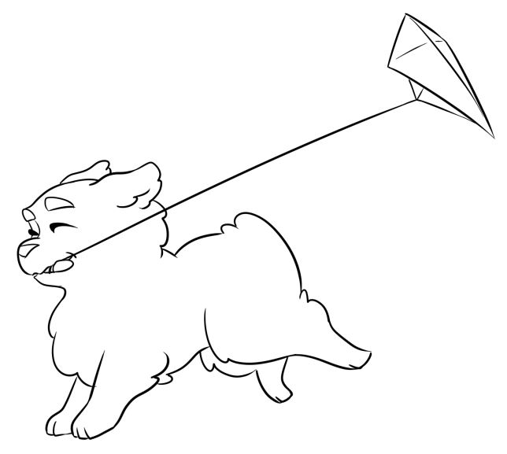

Regn plus stykkerne og sæt streg til det rigtige tal.

|  |  |  |
| --- | --- | --- |
| 4 + 6 |  | 12 |

|  |  |  |
| --- | --- | --- |
| 4 + 10 |  | 13 |

|  |  |  |
| --- | --- | --- |
| 4 + 8 |  | 11 |

|  |  |  |
| --- | --- | --- |
| 4 + 11 |  | 15 |

|  |  |  |
| --- | --- | --- |
| 4 + 7 |  | 10 |

|  |  |  |
| --- | --- | --- |
| 4 + 9 |  | 14 |

Plus LØSNING



Regn plus stykkerne og sæt streg til det rigtige tal.

|  |  |  |
| --- | --- | --- |
| 4 + 6 |  | 12 |

|  |  |  |
| --- | --- | --- |
| 4 + 10 |  | 13 |

|  |  |  |
| --- | --- | --- |
| 4 + 8 |  | 11 |

|  |  |  |
| --- | --- | --- |
| 4 + 11 |  | 15 |

|  |  |  |
| --- | --- | --- |
| 4 + 7 |  | 10 |

|  |  |  |
| --- | --- | --- |
| 4 + 9 |  | 14 |

Plus

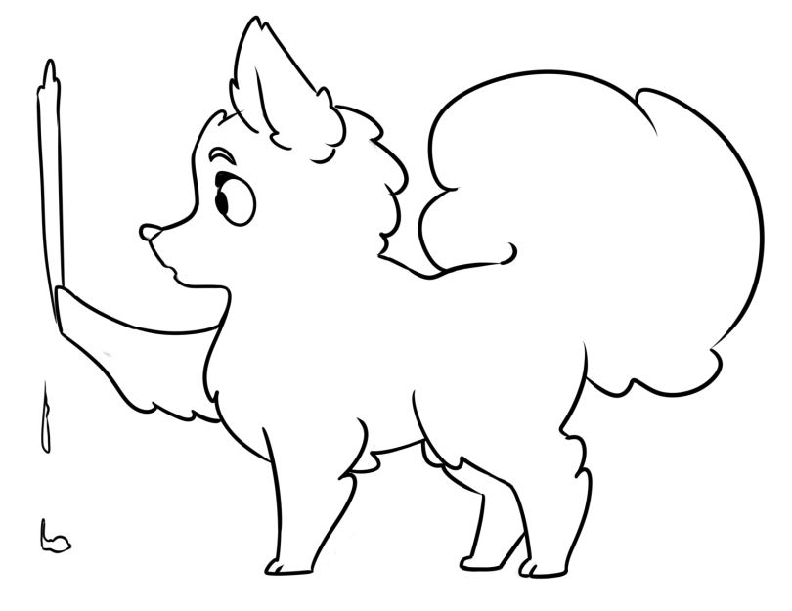

Regn plus stykkerne og sæt streg til det rigtige tal.

|  |  |  |
| --- | --- | --- |
| 5 + 2 |  | 6 |

|  |  |  |
| --- | --- | --- |
| 5 + 4 |  | 10 |

|  |  |  |
| --- | --- | --- |
| 5 + 1 |  | 7 |

|  |  |  |
| --- | --- | --- |
| 5 + 6 |  | 8 |

|  |  |  |
| --- | --- | --- |
| 5 + 5 |  | 9 |

|  |  |  |
| --- | --- | --- |
| 5 + 3 |  | 11 |

Plus LØSNING



Regn plus stykkerne og sæt streg til det rigtige tal.

|  |  |  |
| --- | --- | --- |
| 5 + 2 |  | 6 |

|  |  |  |
| --- | --- | --- |
| 5 + 4 |  | 10 |

|  |  |  |
| --- | --- | --- |
| 5 + 1 |  | 7 |

|  |  |  |
| --- | --- | --- |
| 5 + 6 |  | 8 |

|  |  |  |
| --- | --- | --- |
| 5 + 5 |  | 9 |

|  |  |  |
| --- | --- | --- |
| 5 + 3 |  | 11 |

Plus

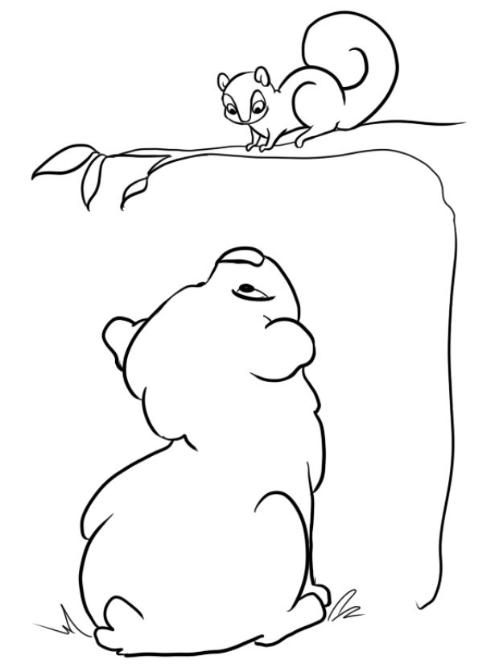

Regn plus stykkerne og sæt streg til det rigtige tal.

|  |  |  |
| --- | --- | --- |
| 5 + 9 |  | 15 |

|  |  |  |
| --- | --- | --- |
| 5 + 6 |  | 12 |

|  |  |  |
| --- | --- | --- |
| 5 + 11 |  | 14 |

|  |  |  |
| --- | --- | --- |
| 5 + 10 |  | 13 |

|  |  |  |
| --- | --- | --- |
| 5 + 7 |  | 11 |

|  |  |  |
| --- | --- | --- |
| 5 + 8 |  | 16 |

Plus LØSNING



Regn plus stykkerne og sæt streg til det rigtige tal.

|  |  |  |
| --- | --- | --- |
| 5 + 9 |  | 15 |

|  |  |  |
| --- | --- | --- |
| 5 + 6 |  | 12 |

|  |  |  |
| --- | --- | --- |
| 5 + 11 |  | 14 |

|  |  |  |
| --- | --- | --- |
| 5 + 10 |  | 12 |

|  |  |  |
| --- | --- | --- |
| 5 + 7 |  | 11 |

|  |  |  |
| --- | --- | --- |
| 5 + 8 |  | 16 |

Plus

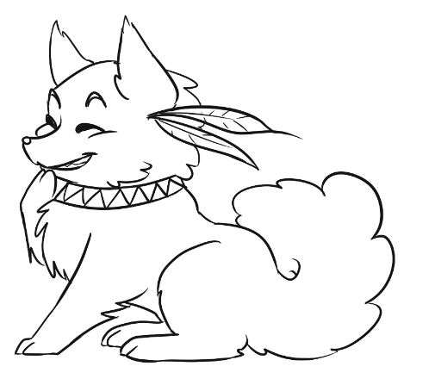

Regn plus stykkerne og sæt streg til det rigtige tal.

|  |  |  |
| --- | --- | --- |
| 6 + 3 |  | 8 |

|  |  |  |
| --- | --- | --- |
| 6 + 2 |  | 7 |

|  |  |  |
| --- | --- | --- |
| 6 + 5 |  | 9 |

|  |  |  |
| --- | --- | --- |
| 6 + 1 |  | 10 |

|  |  |  |
| --- | --- | --- |
| 6 + 6 |  | 11 |

|  |  |  |
| --- | --- | --- |
| 6 + 4 |  | 12 |

Plus LØSNING



Regn plus stykkerne og sæt streg til det rigtige tal.

|  |  |  |
| --- | --- | --- |
| 6 + 3 |  | 8 |

|  |  |  |
| --- | --- | --- |
| 6 + 2 |  | 7 |

|  |  |  |
| --- | --- | --- |
| 6 + 5 |  | 9 |

|  |  |  |
| --- | --- | --- |
| 6 + 1 |  | 10 |

|  |  |  |
| --- | --- | --- |
| 6 + 6 |  | 11 |

|  |  |  |
| --- | --- | --- |
| 6 + 4 |  | 12 |

Plus

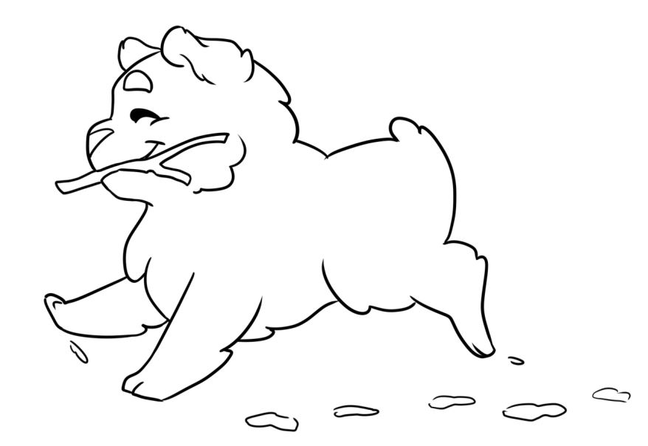

Regn plus stykkerne og sæt streg til det rigtige tal.

|  |  |  |
| --- | --- | --- |
| 6 + 6 |  | 15 |

|  |  |  |
| --- | --- | --- |
| 6 + 11 |  | 16 |

|  |  |  |
| --- | --- | --- |
| 6 + 9 |  | 12 |

|  |  |  |
| --- | --- | --- |
| 6 + 7 |  | 17 |

|  |  |  |
| --- | --- | --- |
| 6 + 10 |  | 14 |

|  |  |  |
| --- | --- | --- |
| 6 + 8 |  | 13 |

Plus LØSNING



Regn plus stykkerne og sæt streg til det rigtige tal.

|  |  |  |
| --- | --- | --- |
| 6 + 6 |  | 15 |

|  |  |  |
| --- | --- | --- |
| 6 + 11 |  | 16 |

|  |  |  |
| --- | --- | --- |
| 6 + 9 |  | 12 |

|  |  |  |
| --- | --- | --- |
| 6 + 7 |  | 17 |

|  |  |  |
| --- | --- | --- |
| 6 + 10 |  | 14 |

|  |  |  |
| --- | --- | --- |
| 6 + 8 |  | 13 |

Plus

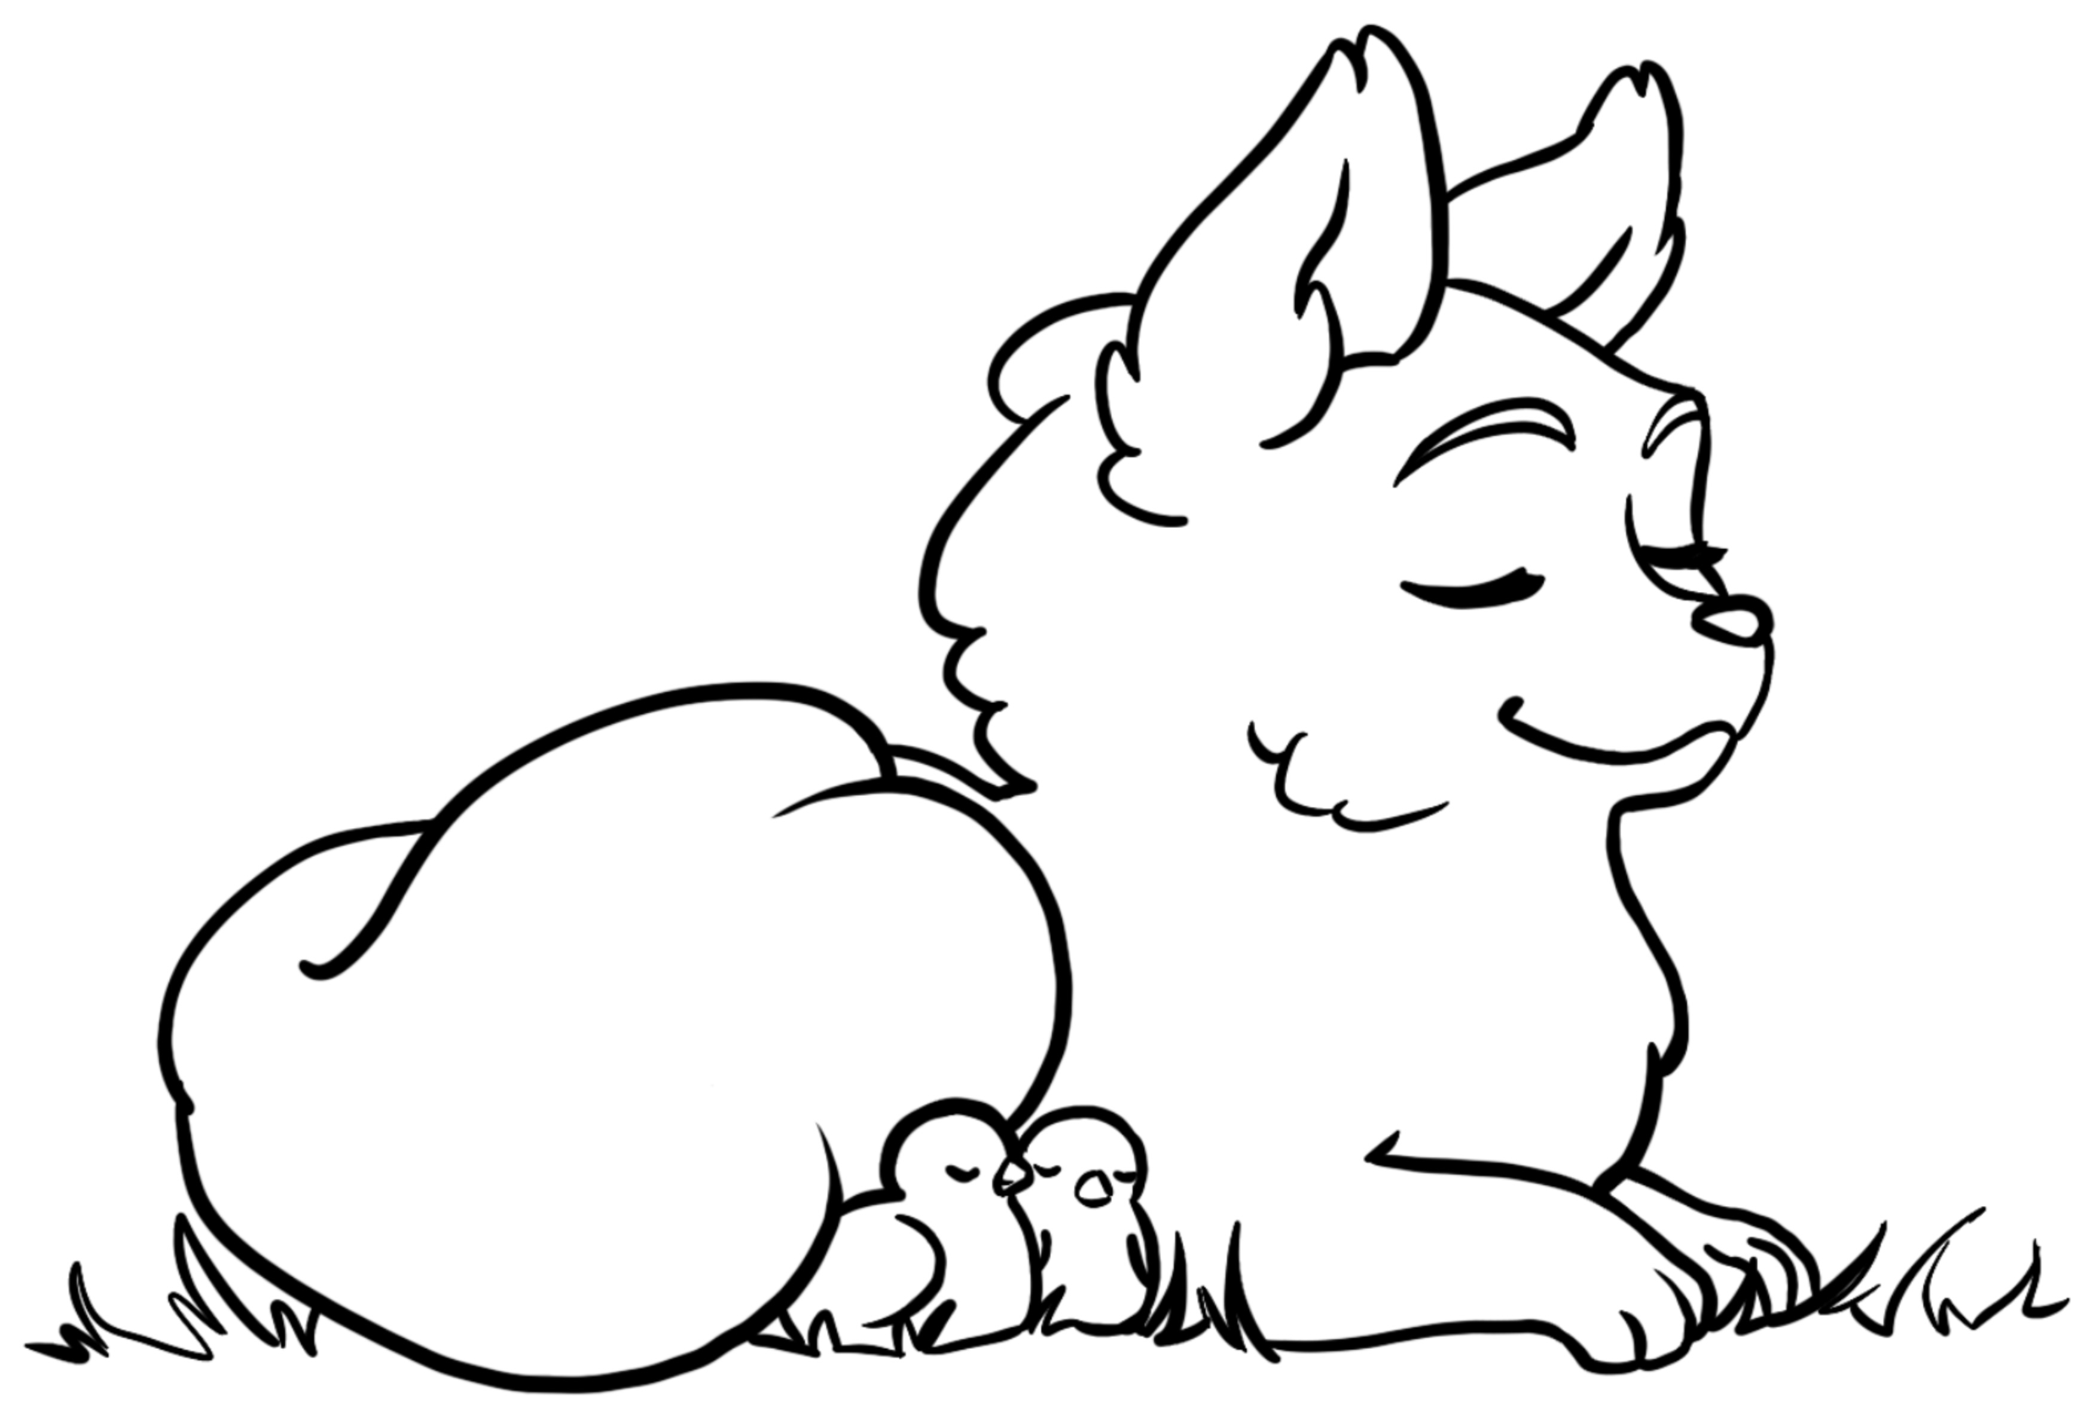

Regn plus stykkerne og sæt streg til det rigtige tal.

|  |  |  |
| --- | --- | --- |
| 7 + 3 |  | 11 |

|  |  |  |
| --- | --- | --- |
| 7 + 4 |  | 9 |

|  |  |  |
| --- | --- | --- |
| 7 + 1 |  | 10 |

|  |  |  |
| --- | --- | --- |
| 7 + 2 |  | 8 |

|  |  |  |
| --- | --- | --- |
| 7 + 6 |  | 12 |

|  |  |  |
| --- | --- | --- |
| 7 + 5 |  | 13 |

Plus LØSNING



Regn plus stykkerne og sæt streg til det rigtige tal.

|  |  |  |
| --- | --- | --- |
| 7 + 3 |  | 11 |

|  |  |  |
| --- | --- | --- |
| 7 + 4 |  | 9 |

|  |  |  |
| --- | --- | --- |
| 7 + 1 |  | 10 |

|  |  |  |
| --- | --- | --- |
| 7 + 2 |  | 8 |

|  |  |  |
| --- | --- | --- |
| 7 + 6 |  | 12 |

|  |  |  |
| --- | --- | --- |
| 7 + 5 |  | 13 |

Plus

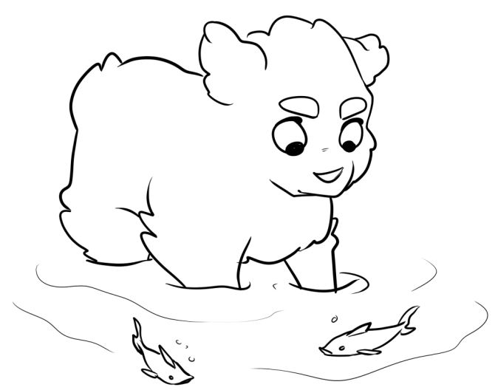

Regn plus stykkerne og sæt streg til det rigtige tal.

|  |  |  |
| --- | --- | --- |
| 7 + 6 |  | 17 |

|  |  |  |
| --- | --- | --- |
| 7 + 10 |  | 16 |

|  |  |  |
| --- | --- | --- |
| 7 + 8 |  | 13 |

|  |  |  |
| --- | --- | --- |
| 7 + 11 |  | 15 |

|  |  |  |
| --- | --- | --- |
| 7 + 9 |  | 14 |

|  |  |  |
| --- | --- | --- |
| 7 + 7 |  | 18 |

Plus LØSNING



Regn plus stykkerne og sæt streg til det rigtige tal.

|  |  |  |
| --- | --- | --- |
| 7 + 6 |  | 17 |

|  |  |  |
| --- | --- | --- |
| 7 + 10 |  | 16 |

|  |  |  |
| --- | --- | --- |
| 7 + 8 |  | 13 |

|  |  |  |
| --- | --- | --- |
| 7 + 11 |  | 15 |

|  |  |  |
| --- | --- | --- |
| 7 + 9 |  | 14 |

|  |  |  |
| --- | --- | --- |
| 7 + 7 |  | 18 |

Plus

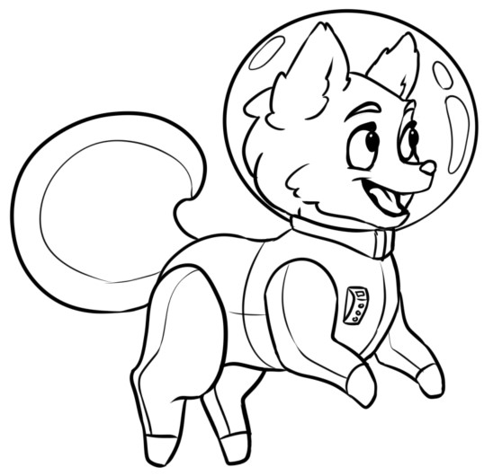

Regn plus stykkerne og sæt streg til det rigtige tal.

|  |  |  |
| --- | --- | --- |
| 8 + 2 |  | 9 |

|  |  |  |
| --- | --- | --- |
| 8 + 1 |  | 12 |

|  |  |  |
| --- | --- | --- |
| 8 + 4 |  | 10 |

|  |  |  |
| --- | --- | --- |
| 8 + 3 |  | 11 |

|  |  |  |
| --- | --- | --- |
| 8 + 6 |  | 14 |

|  |  |  |
| --- | --- | --- |
| 8 + 5 |  | 13 |

Plus LØSNING



Regn plus stykkerne og sæt streg til det rigtige tal.

|  |  |  |
| --- | --- | --- |
| 8 + 2 |  | 9 |

|  |  |  |
| --- | --- | --- |
| 8 + 1 |  | 12 |

|  |  |  |
| --- | --- | --- |
| 8 + 4 |  | 10 |

|  |  |  |
| --- | --- | --- |
| 8 + 3 |  | 11 |

|  |  |  |
| --- | --- | --- |
| 8 + 6 |  | 14 |

|  |  |  |
| --- | --- | --- |
| 8 + 5 |  | 13 |

Plus



Regn plus stykkerne og sæt streg til det rigtige tal.

|  |  |  |
| --- | --- | --- |
| 8 + 6 |  | 17 |

|  |  |  |
| --- | --- | --- |
| 8 + 9 |  | 19 |

|  |  |  |
| --- | --- | --- |
| 8 + 11 |  | 14 |

|  |  |  |
| --- | --- | --- |
| 8 + 7 |  | 18 |

|  |  |  |
| --- | --- | --- |
| 8 + 8 |  | 15 |

|  |  |  |
| --- | --- | --- |
| 8 + 10 |  | 16 |

Plus LØSNING



Regn plus stykkerne og sæt streg til det rigtige tal.

|  |  |  |
| --- | --- | --- |
| 8 + 6 |  | 17 |

|  |  |  |
| --- | --- | --- |
| 8 + 9 |  | 19 |

|  |  |  |
| --- | --- | --- |
| 8 + 11 |  | 14 |

|  |  |  |
| --- | --- | --- |
| 8 + 7 |  | 18 |

|  |  |  |
| --- | --- | --- |
| 8 + 8 |  | 15 |

|  |  |  |
| --- | --- | --- |
| 8 + 10 |  | 16 |

Plus

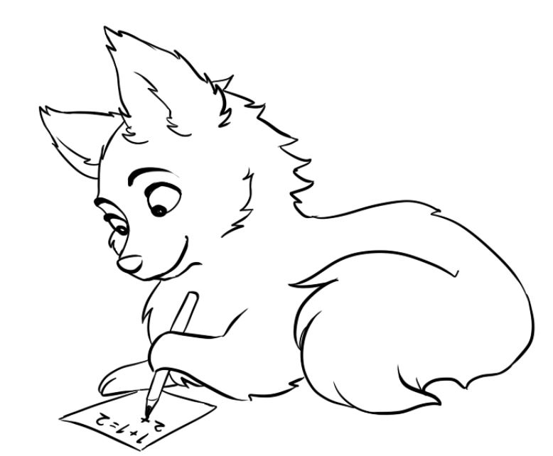

Regn plus stykkerne og sæt streg til det rigtige tal.

|  |  |  |
| --- | --- | --- |
| 9 + 1 |  | 15 |

|  |  |  |
| --- | --- | --- |
| 9 + 4 |  | 10 |

|  |  |  |
| --- | --- | --- |
| 9 + 6 |  | 11 |

|  |  |  |
| --- | --- | --- |
| 9 + 2 |  | 13 |

|  |  |  |
| --- | --- | --- |
| 9 + 5 |  | 12 |

|  |  |  |
| --- | --- | --- |
| 9 + 3 |  | 14 |

Plus LØSNING



Regn plus stykkerne og sæt streg til det rigtige tal.

|  |  |  |
| --- | --- | --- |
| 9 + 1 |  | 15 |

|  |  |  |
| --- | --- | --- |
| 9 + 4 |  | 10 |

|  |  |  |
| --- | --- | --- |
| 9 + 6 |  | 11 |

|  |  |  |
| --- | --- | --- |
| 9 + 2 |  | 13 |

|  |  |  |
| --- | --- | --- |
| 9 + 5 |  | 12 |

|  |  |  |
| --- | --- | --- |
| 9 + 3 |  | 14 |

Plus

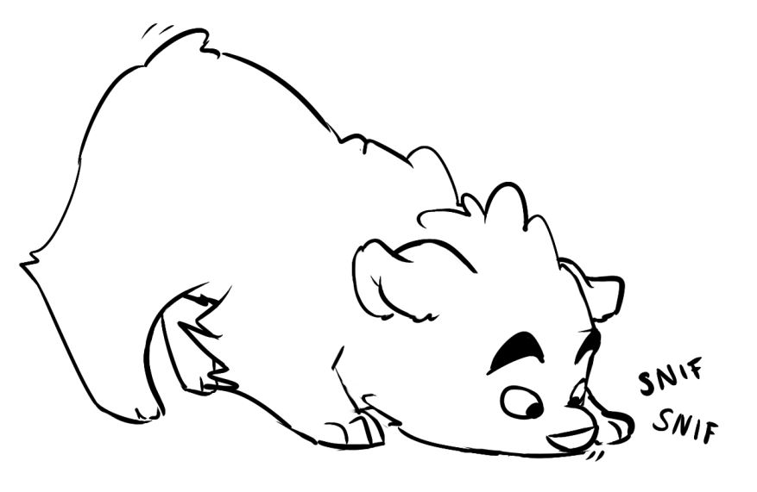

Regn plus stykkerne og sæt streg til det rigtige tal.

|  |  |  |
| --- | --- | --- |
| 9 + 7 |  | 19 |

|  |  |  |
| --- | --- | --- |
| 9 + 10 |  | 17 |

|  |  |  |
| --- | --- | --- |
| 9 + 8 |  | 16 |

|  |  |  |
| --- | --- | --- |
| 9 + 11 |  | 18 |

|  |  |  |
| --- | --- | --- |
| 9 + 9 |  | 20 |

|  |  |  |
| --- | --- | --- |
| 9 + 12 |  | 21 |

Plus LØSNING



Regn plus stykkerne og sæt streg til det rigtige tal.

|  |  |  |
| --- | --- | --- |
| 9 + 7 |  | 19 |

|  |  |  |
| --- | --- | --- |
| 9 + 10 |  | 17 |

|  |  |  |
| --- | --- | --- |
| 9 + 8 |  | 16 |

|  |  |  |
| --- | --- | --- |
| 9 + 11 |  | 18 |

|  |  |  |
| --- | --- | --- |
| 9 + 9 |  | 20 |

|  |  |  |
| --- | --- | --- |
| 9 + 12 |  | 21 |

Plus

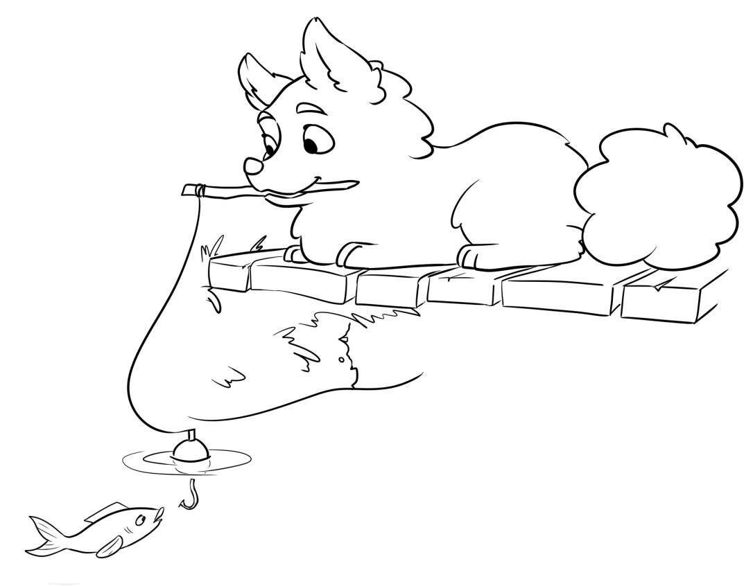

Regn plus stykkerne og sæt streg til det rigtige tal.

|  |  |  |
| --- | --- | --- |
| 10 + 0 |  | 14 |

|  |  |  |
| --- | --- | --- |
| 10 + 1 |  | 10 |

|  |  |  |
| --- | --- | --- |
| 10 + 4 |  | 11 |

|  |  |  |
| --- | --- | --- |
| 10 + 2 |  | 15 |

|  |  |  |
| --- | --- | --- |
| 10 + 3 |  | 12 |

|  |  |  |
| --- | --- | --- |
| 10 + 5 |  | 13 |

Plus LØSNING



Regn plus stykkerne og sæt streg til det rigtige tal.

|  |  |  |
| --- | --- | --- |
| 10 + 0 |  | 14 |

|  |  |  |
| --- | --- | --- |
| 10 + 1 |  | 10 |

|  |  |  |
| --- | --- | --- |
| 10 + 4 |  | 11 |

|  |  |  |
| --- | --- | --- |
| 10 + 2 |  | 15 |

|  |  |  |
| --- | --- | --- |
| 10 + 3 |  | 12 |

|  |  |  |
| --- | --- | --- |
| 10 + 5 |  | 13 |

Plus

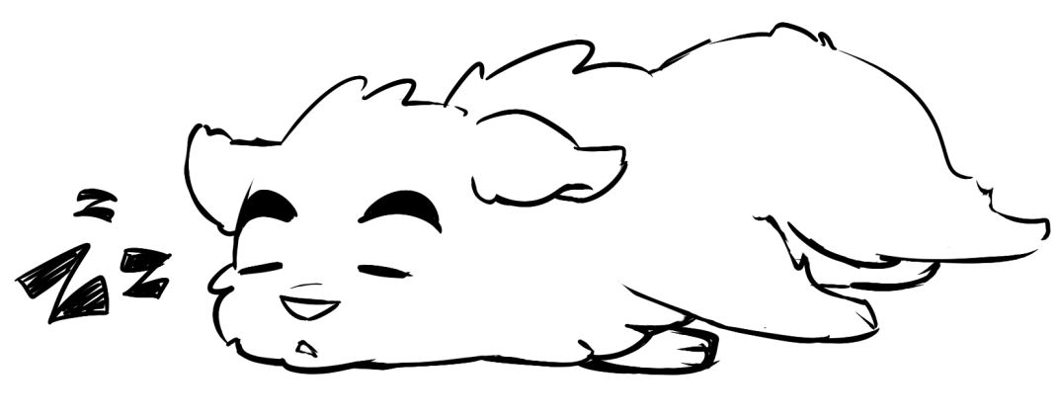

Regn plus stykkerne og sæt streg til det rigtige tal.

|  |  |  |
| --- | --- | --- |
| 10 + 10 |  | 19 |

|  |  |  |
| --- | --- | --- |
| 10 + 6 |  | 20 |

|  |  |  |
| --- | --- | --- |
| 10 + 9 |  | 16 |

|  |  |  |
| --- | --- | --- |
| 10 + 5 |  | 15 |

|  |  |  |
| --- | --- | --- |
| 10 + 8 |  | 17 |

|  |  |  |
| --- | --- | --- |
| 10 + 7 |  | 18 |

Plus LØSNING



Regn plus stykkerne og sæt streg til det rigtige tal.

|  |  |  |
| --- | --- | --- |
| 10 + 10 |  | 19 |

|  |  |  |
| --- | --- | --- |
| 10 + 6 |  | 20 |

|  |  |  |
| --- | --- | --- |
| 10 + 9 |  | 16 |

|  |  |  |
| --- | --- | --- |
| 10 + 5 |  | 15 |

|  |  |  |
| --- | --- | --- |
| 10 + 8 |  | 17 |

|  |  |  |
| --- | --- | --- |
| 10 + 7 |  | 18 |